## horizontal line

Retailer Reward System

08.2024

**─**

Sahu Rabi Narayan

Infosys

# 

# 

# 

# 

# 

# 

# Overview

#### **1. Introduction**

The Retailer Reward System application provides a rewards program to customers, awarding points based on each recorded purchase. Points are calculated based on the amount spent in each transaction.

The application processes transaction records over a three-month period and calculates the reward points earned by each customer on a monthly basis, as well as their total points.

# 

# System Architecture

The application is built using Spring Boot and provides RESTful APIs for calculating and retrieving reward points.

## Components

* **Backend:** Java 8, Spring Boot 2.6.3
* **Database:** H2 Database for storing transaction records.
* **APIs:** Exposes endpoints for reward calculation and retrieval.

# API Documentation

## Get /api/reward

**Description:** Calculates and retrieves the reward points for each customer per month.

**Example Request:** GET <http://localhost:9010/retailer-rewards/api/reward>

**Sample Response:**

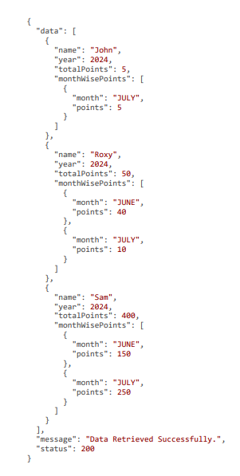

## Swagger Documentation

The Swagger UI for API documentation can be accessed at: <http://localhost:9010/retailer-rewards/swagger-ui.html>

# Database Schema

The application uses a single table to store transaction records, which is processed to calculate rewards.insert queries available in src/java/resource

## H2 Database Console URL:

<http://localhost:9010/retailer-rewards/h2-console/>

# Installation

**Clone the Repository:**

<https://github.com/ravirazsahu/spring-boot-rewards-system.git>

**Navigate to the Project Directory:** cd spring-boot-rewards-system

**Build the Project Using Maven:** mvn clean install

**Run the Application:** The application will be available at http://localhost:9010/retailer-rewards.

# Flow Diagram

The flow diagram illustrates the high-level process of handling API requests in the Retailer Reward System application.

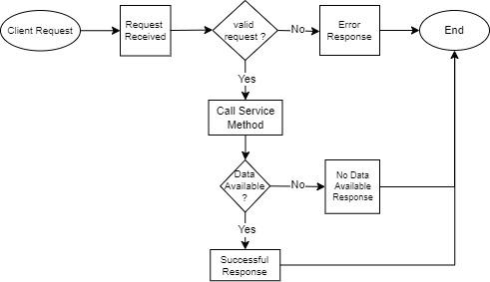

# Conclusion

This document offers a detailed overview of the Retailer Reward System application. It covers the application's architecture, core functionalities, and the APIs provided.